

**Local Police Report**

**Portobello Community Council**

**28th August 2017**

(Non Restricted)

**Constable Matt McPherson E0002**

**Local Priorities**

‘Your View Counts’ is a survey that has recently been released by Police Scotland. It seeks to identify what the community’s priorities are moving forward. All residents are encouraged to complete the survey.

The Community Alcohol Partnership has been meeting regularly and has a strong group up and running across much of Edinburgh, particularly the North East. It seeks to bring together businesses, youth groups and the police to tackle the issues surrounding underage drinking. From school talks to foot patrols to criminal enquiries being undertaken, we are keeping an eagle eye on related concerns and taking firm action accordingly. The CAP recently held free training for all small businesses in the local area.

If there is anything you feel should be brought to the attention of the CAP please let me know.

If you wish to chat anything through with me please let me know.

The priorities affecting the community of Portobello, in line with the ‘Multi-Member Ward Plan’ are:

* Anti-social behaviour
* Housebreaking and other thefts
* Drug dealing and substance misuse
* Assault and violent crime

Full details regarding the above can be found on the Police Scotland website in the ‘Your Community’ section.

Since October 2016, we have had the luxury of two beat officers within Portobello. However, due to some staff movements, Constable David Love will be moving from Portobello to the neighbouring beat of Northfield and the Durhams. We will continue to work closely together, so please feel free to contact either of us, though it will mean that I will be the primary contact for issues surrounding Portobello.



*This is to prove we have not fallen out*

**Local Updates, Events and Initiatives**

Local Criminality

* Overall, violent crime is down in this quarter for Portobello. Common assaults are down slightly on last year’s figures, as well.
* We continue to have low levels of alcohol related violence and antisocial behaviour.
* Thefts to motor vehicles and lock fast places are down in Portobello compared to last year.
* Have been a number of housebreakings in the area. Please note the new Neighbourhood Alert scheme attached.
* Following the spate of pedal-cycle thefts earlier on in the year, several young persons were identified, cautioned and charged. On some occasions, these thefts were linked to more serious levels of criminality, including theft by housebreaking. One particular suspect was identified as being potentially involved, but was released with insufficient evidence. However, since this occasion his level of offending has reduced.
* Without any intention of causing panic or alarm, there have been a small number of thefts by housebreakings to families from an Asian background. It appears as though some criminals have identified these members of our community as being likely to hold large amounts of cash and high value jewellery. I have popped in to the Pakistani Educational and Cultural Centre, Fishwives Causeway, and spoken with the Imam to distribute some security advice. It would be appreciated if all neighbours could perhaps advise members of our community who may be affected.
* A week-long antisocial behaviour operation took place in Magdalene, where I assisted colleagues in carrying out high visibility patrols within that community. Some of the youths are the same as the ones who hang around Portobello, and the week was a good opportunity to engage proactively with them. I have had the opportunity to take some youths on a diversionary motorcycle course, and plan on getting them involved in the regular meetings of youth group next month.
* Operation Pumpkin is being planned to cover events surrounding Halloween this year, during such time we anticipate high levels of disruptive behaviour. It will involve additional resources being deployed within hotspot areas, and close partnership working with the fire service and Holyrood Park rangers.

Caravans at Kings Place

* Having made good progress in partnership with the Council in working towards a joint solution, there has been a lack of progress in getting the caravans moved on. All caravans were issued with formal notices by the police and Council, and considerable effort was made to contact to all owners. However, due to initial actions not being enforceable, we continue to work to identify further solutions.
* Due to a lack of legal options, both the police and Council have not been in a position to start removing, fining or charging caravans and owners. Therefore the problem has simply continued in an unmanaged to the concern of many residents. Getting a Traffic Regulation Order on this site is currently being explored as an option, but this may take many more months.
* There continue to be almost no complaints from residents regarding antisocial behaviour or severe litter at this site.
* A meeting is planned this week with the Council – I will report back on this. Please feel free to request an update from me by email at any time.

Road Traffic

* Following a road traffic initiative over the summer holidays, numerous fixed penalty tickets were issued within the area to drivers flouting the 20mph limit. The main culprit in Portobello is Joppa Road, along with vehicles taking shortcuts through the Coillesdenes.
* If you have particular streets in mind where it would be useful for PC Love and I to hang about with a speed gun, please let us know.
* With the schools now back, we are continuing to regularly police the streets surrounding Towerbank Primary School in order to enforce the pedestrianised zone. We have a meeting in the diary this Friday with the school head to chat through any emerging concerns.
* Problems within Park Avenue will undoubtedly crop up again with Portobello High School back in action. PC Love and I will continue to give the area as much attention as we can, with a particular focus at the busiest periods.
* STOP PARKING IN FRONT OF BINS. That is all. See attachment.

Organised Crime

* PC Love and I are leading an initiative to arrest people within our community who are wanted on warrant. When a warrant is issued by the Courts it is allocated to a police officer for progression, but our colleagues in response are so busy they can be difficult to get round to. Attempting to apprehend wanted persons assists the disruption of crime.

**Contact Us**

As your new local beat officers, David and Matt are very happy to be contacted by the local community should you wish to seek advice, step-up police presence within a specific area or if you would like them to attend at a local event. Feel free to email them, telephone them on 101 or attend at their surgery.

The 101 telephone system continues be the key facility for contacting police at any time other than in an emergency. The system charges a flat rate of 15p to help cover its cost, and allows any person to report an historic crime, speak to an officer or request updates for an ongoing enquiry. This line is available all day every day, and has alleviated pressure on the 999 system which continues to be used for emergencies. Should you wish to contact Police Scotland from out-with Scotland please telephone 01786289070.

CrimeStoppers allows members of the public to anonymously report crime or provide the authorities with intelligence. They can be telephoned on 0800555111 and are independent of Police Scotland.

The Police Scotland website continues to provide: updates on policing news, events, initiatives and local safety advice. It also contains the ability to contact the police about any non-urgent matter, whether it be a compliment or complaint, at the address [www.scotland.police.uk/contact-us/contact-us-form](http://www.scotland.police.uk/contact-us/contact-us-form).

Follow us on Twitter: @EdinPolNE

Like us on Facebook: search ‘Police Scotland’ and ‘Edinburgh Police Division’



Portobello Police Station

118 Portobello High Street

Edinburgh

EH15 1AL

Tel: 101

[www.scotland.police.uk](http://www.scotland.police.uk)

matthew.mcpherson@scotland.pnn.police.uk

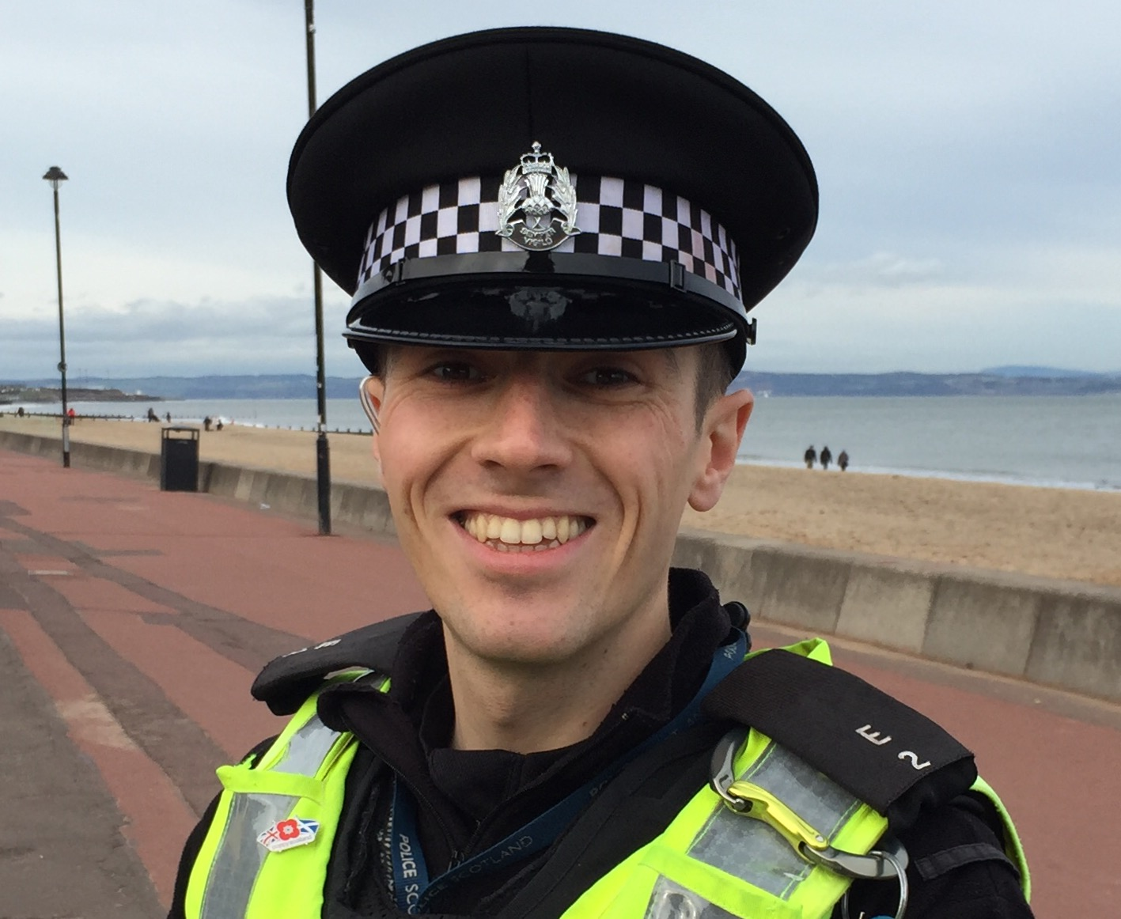

Dear Resident,

As the beat officer for Portobello, a number of people have been in touch with me to vent their frustration about vehicles routinely parking in front of bins.

Without wishing to labour an overly obvious point, if vehicles are parked in front of bins the Council cannot collect them. This in turn means that bins can be left for days before the Council get to them again, which has a detrimental effect on living standards for all residents.

It is an offence to park your vehicle in an obstructive manner. I have the power to uplift and remove obstructively parked vehicles from the public road. Not only does the owner have to pay for their vehicle upon collection; they are also liable to prosecution. I am most reluctant to go down this road, but I will have no option but to escalate my actions if people repeatedly offend.

We all know that parking can be a nightmare on many of our streets, so please work with me to ensure everyone parks responsibly.

I do intend on doing all I can to support this community, so please do not hesitate to contact me regarding this or any other matter.

Best wishes,

## PC Matthew McPherson

E0002/12255

Portobello Beat Officer



[www.neighbourhoodwatchscotland.co.uk](https://member-registration.neighbourhoodalert.co.uk/91/Join)

